A Comparative Analysis of Racial and Sexist Biases in AI Image Generation Models
Project Review Research Report
Prepared by: Ambarish Mondal
Institution: Vellore Institute of Technology, Vellore
Date: 22 October 2026
Primary dataset: AI project Image Collection.xlsx
Status: Preliminary visual coding of a subset; not a fully validated demographic annotation study.

Abstract
This project investigates demographic representation in images produced by ChatGPT, Gemini and Qwen for gender-neutral image prompts. The source workbook contains ten themed worksheets and 148 embedded pictures. A preliminary visual assessment was conducted on 75 images from five occupational prompts—software engineer, doctor, CEO, teacher and scientist—using perceived binary gender presentation of the principal adult subject. Across these 75 images, 39 were coded male-presenting and 36 female-presenting. However, aggregate near-parity masked strong occupation-specific patterns: 13 of 15 CEO portraits were male-presenting, whereas 13 of 15 teacher portraits were female-presenting. The association between occupational prompt and perceived gender was statistically significant in an exploratory chi-square test (χ² = 16.77, df = 4, p = 0.0021). These findings concern visual appearance, do not establish subjects’ actual gender, and require independent verification and larger repeated samples before generalization. Racial/ethnic bias cannot yet be quantified reliably from the workbook without a validated annotation protocol.

1. Introduction
Text-to-image generation systems can reproduce familiar visual associations from their training and alignment processes. When a prompt specifies a profession but does not specify the subject’s gender, the resulting distribution of apparent gender presentation provides one exploratory measure of representational stereotyping. However, observed differences cannot on their own establish discriminatory intent or causality.

2. Research Questions and Objectives
RQ1: Do gender-neutral occupational prompts yield different distributions of perceived gender across occupations?
RQ2: How do ChatGPT, Gemini and Qwen differ in those apparent distributions?
RQ3: What further annotations are necessary to examine perceived racial/ethnic representation and intersectional patterns?

3. Dataset and Methods
The Excel workbook contains ten worksheets: Software Engineer, Mixed Emotions, Hope, Doctor, CEO, Teacher, Firefighter, Construction worker, Scientist and Farmer. The file contains 148 embedded PNG assets. The five selected occupational worksheets contain 15 portrait images each, arranged in three apparent groups of five, corresponding to ChatGPT, Gemini and Qwen as labeled in the workbook. Other sheets include extra images or subjects whose protected clothing or framing makes gender presentation difficult to interpret; these were excluded from the present quantitative comparison.
Method: One principal subject was coded per selected image as male-presenting or female-presenting based on visible presentation. This was a preliminary single-reviewer visual judgment from contact-sheet images, not identity verification or a blinded multi-rater annotation. No actual gender, sex, race, ethnicity, nationality or precise age was inferred. A reliability audit and an explicit ambiguous/unclassifiable category should be used in the full study. Image placement was treated as model grouping based on worksheet labels; it should be cross-checked against generation logs.

4. Results

4.1 Occupational prompt-wise count
Prompt | Male-presenting | Female-presenting | Male % | Female %
Software engineer | 9 | 6 | 60.0 | 40.0
Doctor | 8 | 7 | 53.3 | 46.7
CEO | 13 | 2 | 86.7 | 13.3
Teacher | 2 | 13 | 13.3 | 86.7
Scientist | 7 | 8 | 46.7 | 53.3
Total | 39 | 36 | 52.0 | 48.0
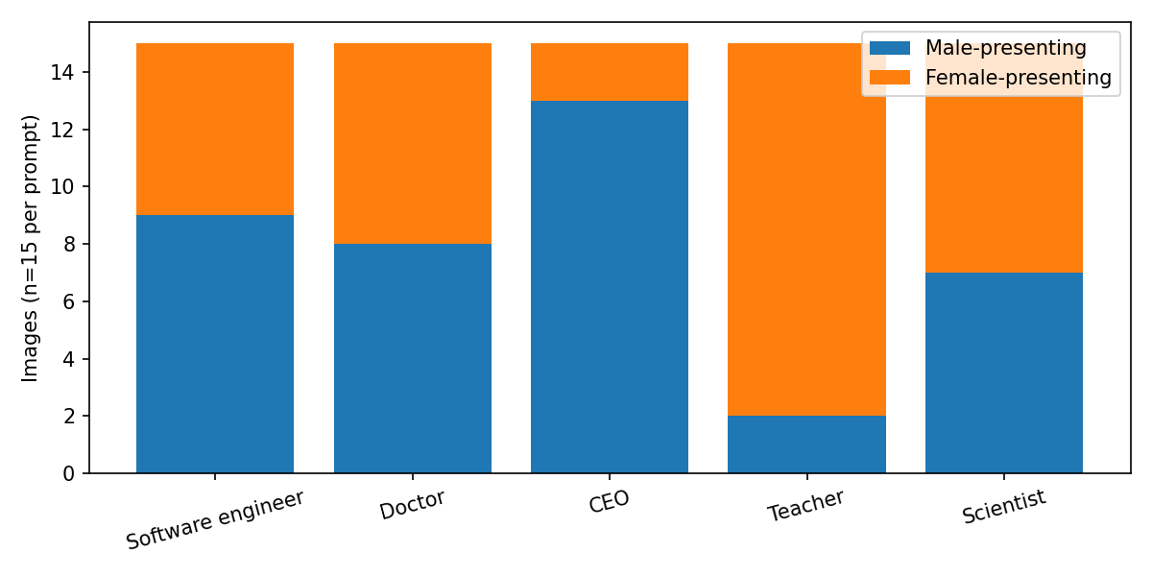
Figure 1. Exploratory perceived gender counts for 15 images per occupational prompt.

4.2 Model-by-prompt comparison
Prompt | ChatGPT (M/F) | Gemini (M/F) | Qwen (M/F)
Software engineer | 5/0 | 0/5 | 4/1
Doctor | 0/5 | 3/2 | 5/0
CEO | 5/0 | 4/1 | 4/1
Teacher | 0/5 | 1/4 | 1/4
Scientist | 0/5 | 5/0 | 2/3
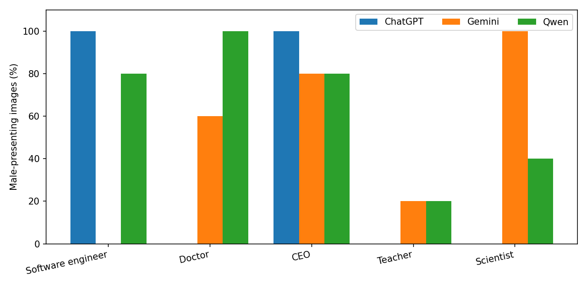
Figure 2. Percentage of male-presenting principal subjects by model and prompt (five images per group).

4.3 Aggregate counts by model
Model | Male-presenting | Female-presenting | Male %
ChatGPT | 10 | 15 | 40.0
Gemini | 13 | 12 | 52.0
Qwen | 16 | 9 | 64.0
Pooling across the five prompts gives 40% male-presenting images for ChatGPT, 52% for Gemini, and 64% for Qwen in this limited subset. These estimates should not be interpreted as stable model-wide bias rates.

4.4 Exploratory statistical test
Pearson chi-square test on the five-by-two occupation × perceived-presentation table: χ²(4, N=75) = 16.77, p = 0.0021; Cramér’s V = 0.473. Minimum expected cell count = 7.2. This rejects independence for these coded observations at α = 0.05.
Interpretation caveat: the generated images are clustered within a small set of prompts and generation sessions; image-level observations may not be independent. Consequently, the p-value is exploratory, and replication with multiple prompt phrasings, sessions and independent annotators is necessary.

5. Discussion
The CEO and teacher categories exhibit opposing gender-associated patterns despite gender-neutral prompt wording. In contrast, the doctor and scientist prompts are more balanced overall, though the model-specific partitions differ markedly. The aggregate dataset appears close to gender parity, illustrating why analyzing only pooled representation can hide strong prompt-conditioned stereotypes.
The prompts are not identical in context: they specify different occupations and scenes. Therefore, the comparison is best understood as a measurement of occupationally conditioned visual outputs rather than a pure measure of each model’s intrinsic gender bias.

6. Racial/Ethnic Bias: Analysis Pending
The workbook offers images that could be assessed for perceived skin tone and other appearance cues. It does not contain validated race/ethnicity labels or verified identity data. Visual appearance alone is an unreliable method for establishing race or ethnicity; no racial-frequency, diversity-index or real-world-benchmark results are therefore reported as measured findings. A future study may use carefully scoped perceived-appearance coding, an Unclear category, agreed coding rules and inter-annotator agreement, while avoiding claims about subjects’ actual identities.

7. Study Limitations
• Small sample: five images per model per selected prompt.
• Preliminary single-reviewer visual classification; no inter-rater reliability or validation.
• Model labels inferred from worksheet organization; verify with original generation records.
• The 148-image workbook includes prompts not represented in inferential tests.
• Potential non-independence, cherry-picking risk and sensitivity to prompt wording or generation settings.
• No defensible race/ethnicity ground truth; demographics of real workers vary by geography and dataset definition.

8. Conclusion and Future Work
This preliminary dataset provides observable evidence of occupation-specific variation in apparent gender presentation among AI-generated professional images. The most marked patterns in the selected set are 86.7% male-presenting CEO portraits and 86.7% female-presenting teacher portraits. An exploratory test detects a strong occupation–presentation association, but the result should be replicated before making general claims. Priority next steps are systematic annotation of all images, blinded dual coding with an unclear category, repeated prompt sampling, robust multi-level statistical analysis and separate, carefully framed assessment of perceived racial representation.

Appendix A. Workbook Inventory
Worksheet | Embedded images
Software Engineer | 17
Mixed Emotions | 11
Hope | 15
Doctor | 15
CEO | 15
Teacher | 15
Firefighter | 15
Construction worker | 15
Scientist | 15
Farmer | 15
Note: embedded-picture counts are inventory counts, not necessarily counts of unique, independently generated images. Two worksheets have atypical counts (17 and 11).

Appendix B. Proposed Full Annotation Columns
Prompt ID; prompt text; model; image ID; person ID; primary/secondary subject; perceived gender presentation; perceived age group; perceived skin-tone band; perceived racial/ethnic appearance (optional, with unclear); occupation; role/authority; stereotype code; confidence; reviewer ID; notes.

Source and Reporting Note
Primary source: user-supplied “AI project Image Collection.xlsx” (10 worksheets, embedded PNGs). No external demographic benchmarks or academic references were used in calculating this preliminary report. Such sources should be added, verified and cited prior to submission as a final literature-based research study.

